**CHEMISTRY 12 ATCHE**

**Organic Chemistry TEST**

**Recommended time: 55 minutes**

**Total marks**

**/ 55**

Name: _____________________________________________________

Teacher: _____________________________________________________

This test is in two parts.

**Part 1:** Multiple choice style consisting of (10) questions.

Each question is worth 1 mark.

Write your answers in the table provided.

Attempt ALL Questions

**Part 2:** Short questions and an extended answer question worth 45 marks.

Write all answers in the spaces provided.

The marks allocated to each question are shown next to each question.

**PART ONE: MULTIPLE CHOICE QUESTIONS (10 MARKS)**

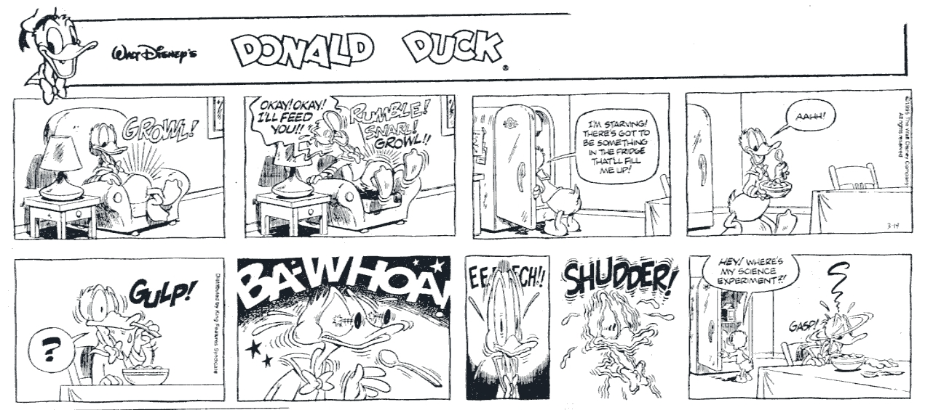

**Place your answers in the table located at the bottom of page 4.**

1. How many primary alcohols have the molecular formula C4H9OH?

(a) 0

(b) 1

(c) 2

(d) 3

2. Consider the following substances:

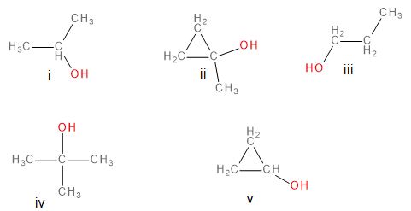

Which of the above are secondary alcohols?

1. i and iii
2. i, iii, and iv
3. i and v
4. ii and v

3. Substance **X** has an empirical formula of C2H4O. Which one of the following could **not** be substance **X**?

(a) methyl methanoate

(b) ethyl ethanoate

(c) butanoic acid

(d) methyl propanoate

4. Which one of the following compounds will be readily oxidised to form a carboxylic acid?

1. CH3CH2CH(OH)CH3
2. HOC(CH3)3
3. CH3CH2COOCH3
4. CH3CH2CHO

5. Which one of the following pairs of compounds would form methyl propanoate when warmed with concentrated sulfuric acid?

(a) CH4 and CH3CH2COOH

(b) CH3OH and CH3CH2CH2OH

(c) CH3OH and CH3CH2COOH

(d) HCOOH and CH3CH2CH2OH

6. Consider the molecule below.



Which one of the following will this molecule **not** react with?

(a) dilute hydrochloric acid

(b) sodium hydrogencarbonate solution

(c) sodium chloride solution

(d) sodium hydroxide solution

7. Which one of the following is the correct half-equation for the oxidation of propan-1-ol to propanoic acid?

(a) CH3CH2CH2OH(aq) + H2O(ℓ) → CH3CH2COOH(aq) + 2 H+(aq) + 2 e–

(b) CH3CH2CH2OH(aq) → CH3CH2CHO(aq) + 2 H+(aq) + 2 e–

(c) CH3CH2CH2OH(aq) + H2O(ℓ) → CH3CH2COOH(aq) + 4 H+(aq) + 4 e–

(d) CH3CH2CH2OH(aq) + O2(g) → CH3CH2COOH(aq) + H2O(ℓ)

1. Which one of the following substances would likely have the **lowest** solubility in water?
2. Pentanoic acid
3. Propan-2-ol
4. Butanal
5. Hexan-3-one
6. Which of the following molecules can exist as a pair of geometric isomers?
7. pent-2-ene
8. 2-methylbut-2-ene
9. hex-1-ene
10. 1,4-dibromo-2,3-dimethylbut-2-ene
11. I and III only
12. I and IV only
13. II, III and IV only
14. I, II, III and IV
15. An unknown colourless liquid was subjected to a number of tests, the observations of which are shown in the table below.

|  |  |
| --- | --- |
| **Test** | **Observation** |
| The liquid was added to a solution of sodium carbonate | The liquids mixed, but no reaction was observed |
| The liquid was shaken with bromine water | The bromine water went from orange to colourless |
| The liquid was mixed with sulfuric acid and a solution of sodium dichromate | The sodium dichromate turned from orange to green |

Which one of the following represents a possible structure for the unknown liquid?

1. CH3CH2CH2CH2CH2OH
2. CH2(OH)CH2CHCHCH2COOH
3. (CH3)2C(OH)CH2CHCH2
4. CH3CH2CHCHCH2CHO

**END OF MULTIPLE CHOICE SECTION**

**Place Your Multiple Choice answers in the table below:**

|  |  |  |  |  |  |  |  |  |  |
| --- | --- | --- | --- | --- | --- | --- | --- | --- | --- |
| **1** | **2** | **3** | **4** | **5** | **6** | **7** | **8** | **9** | **10** |
|  |  |  |  |  |  |  |  |  |  |

**PART TWO: SHORT ANSWER QUESTIONS (45 marks)**

**Question 11 (6 marks)**

Name and draw the structural formula for each of the following:

1. An amine containing three carbon atoms per molecule.

|  |
| --- |
| Structure:  NAME: _____________________  (2 marks) |

1. A tertiary alcohol containing four carbon atoms per molecule.

|  |
| --- |
| Structure:  NAME: _______________________  (2 marks) |

(c) The trans isomer of the alkene C3H4Cl2.

|  |
| --- |
| Structure:  NAME: _____________________  (2 marks) |

**Question 12 (3 marks)**

Complete the following table showing the structure and names of three organic compounds.

|  |  |
| --- | --- |
| **Structure** | **IUPAC Name** |
|  | methyl propanoate |
|  | 3-hexanone |
|  |  |

**Question 13 (6 marks)**

Complete the table by drawing the structure and giving the IUPAC name of the organic compounds that match each of the following descriptions.

|  |  |  |
| --- | --- | --- |
| **Description** | **Structure** | **IUPAC name** |
| A saturated secondary alcohol containing 10 hydrogen atoms |  |  |
| An ester that is an isomer of pentanoic acid and can react with NaOH(aq) to form ethanol |  |  |
| A hydrocarbon that could be used to make 1,2-dichloromethylpropane via an addition reaction |  |  |

**Question 14 (5 marks)**

Potassium peroxymonosulfate (KHSO5) is a powerful oxidising agent used as “Spa Shock” to oxidise organic wastes in spa baths and small swimming pools. The HSO5¯ ion reduces to HSO4¯

(a) Write a balanced half equation for the reduction of HSO5¯ to HSO4¯

_______________________________________________________________________

(1 mark)

(b) KHSO5 is a strong oxidant and can be used to oxidise propan-1-ol. Write the half equation for the complete oxidation of propanol. (Note: this is NOT a combustion process.)

_______________________________________________________________________

(2 marks)

(c) Write the final overall redox equation for this reaction:

_______________________________________________________________________

(2 marks)

**Question 15 (3 marks)**



Serine, whose structure is shown below, is required for production of antibodies. It contains three functional groups labelled A,B and C. Name each of the three functional groups

A: ____________________________

B: ____________________________

C: ____________________________

**C**

**A**

**C**

**C**

**C**

**B**

**Question 16 (4 marks)**

The following reaction sequence can be used to produce ethyl ethanoate.

Ethene

Acetic (Ethanoic) acid

Ethanol

Ethyl ethanoate

Steam

*Concentrated sulfuric acid catalyst*

*Phosphoric acid catalyst*

**STEP 1**

**STEP 2**

(a) Consider Step 1 and Step 2 in this reaction sequence. (Note that phosphoric acid and sulfuric acid act as catalysts in this reaction sequence).

(i) Write the equation for Step 1 and explain why it is described as an addition reaction. (2 marks)

|  |
| --- |
|  |
|  |
|  |

(ii) Write the equation for Step 2 and explain why it is described as a condensation reaction. (2 marks)

|  |
| --- |
|  |
|  |
|  |

**Question 17 (7 marks)**

Consider the two molecules below.

**Molecule A Molecule B**



(a) Write the IUPAC name of the two molecules. (2 marks)

Molecule A

__________________________________________________________________________

Molecule B

__________________________________________________________________________

(b) Describe a chemical test that could be used to distinguish between them. State the expected observations for both substances. (5 marks)

|  |  |  |
| --- | --- | --- |
| **Substance** | **Description of chemical test** | **Expected observations** |
| **Molecule A** |  |  |
| **Molecule B** |  |

**Question 18 (11 marks)**

Dopamine is a primary amine that acts as a neurotransmitter, a chemical that send signals between nerve cells. Levels of dopamine in the brain have been linked to a number of medical conditions, including Parkinson’s disease and ADHD. Dopamine contains carbon, nitrogen, hydrogen and oxygen. In this question you will work out the formula of dopamine.

Two samples of were analysed to determine its empirical formula.

A 12.1 g sample was combusted in oxygen and produced 27.6 g of carbon dioxide and

7.87 g of water.

A separate 17.2 g sample was found to contain 1.57 g of nitrogen.

(a) Determine the empirical formula of dopamine (6 marks)

See over the page

(b) Dopamine is a weak monoprotic base (it can only accept one proton). 10.0 g of dopamine was dissolved in distilled water and the solution made up to 250.0 mL. When titrated against 0.250 mol L-1 hydrochloric acid, 25.00 mL of this solution required 26.1 mL of the acid for neutralisation.

From this data, calculate the molecular mass of dopamine, and hence determine the molecular formula of dopamine. (5 marks)

END OF TEST